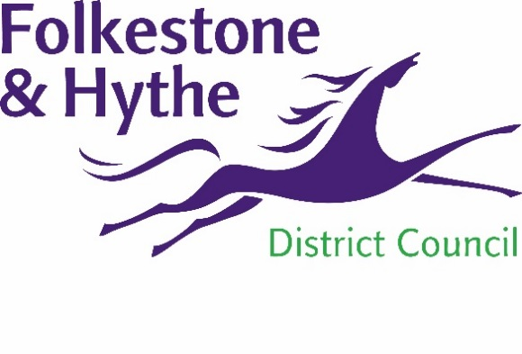
NEWS RELEASE

15 October 2021

GREEN LIGHT FOR NEW HOMES DEVELOPMENT
An ambitious scheme to build more than 70 new homes on a derelict site in Folkestone has been boosted with a £1.15 million government grant.
It was announced earlier this week that the development of Biggins Wood is to receive a share of the Brownfield Land Release Fund (BLRF) from the Department for Levelling Up, Housing and Communities.
The funding will enable remediation work to begin on the former brickworks site early next year. This will involve working with ecologists to clear the 10 acre site and prepare it for the development.
Following the purchase of the site in 2016, it was agreed by F&HDC’s cabinet in July 2019 that a scheme would be taken forward to create 77 homes –23 of which will be for affordable rent – and 5,600 square metres of commercial space. The pandemic stalled the plans to develop the site so the award of this grant will get the project back on track.
Councillor John Collier, F&HDC Cabinet Member for Property Management and Grounds Maintenance, said: “We are delighted to receive this grant which will accelerate our plan to bring forward new homes for residents, whilst at the same time creating more job opportunities for our district.
“We are pleased to be able to prepare for making a start on clearing this derelict and unsightly area of the district and enable it to be developed to create a thriving community through new housing and by boosting the local economy.”
The 23 affordable homes will be will owned and managed by the council’s housing team and will be offered to people on the housing waiting list.
For more about the Brownfield Land Release Fund visit gov.uk/government/news/thousands-of-new-homes-to-be-built-and-derelict-land-transformed
Ends

Notes to Editors:
For more information, please email communications@folkestone-hythe.gov.uk

Follow us on Facebook: @FolkestoneandHytheDC
Follow us on Twitter: @fstonehythedc
Follow us on Instagram: @folkestonehythedc
Follow us on LinkedIn: Folkestone & Hythe District Council

